**EXPLORE THE WORLD WITH SHEAFE’S FLAT BLUEBIRD**

Due: Friday, January 20, 2012

STUDENT NAME: ________________________________________________ ROOM ________________

Here are some more facts about Antarctica:

Wow! I’m glad I’m visiting Antarctica in the summer! Did you know that Antarctica’s seasons are the opposite of ours? That’s because the earth revolves around the sun and tilts on its axis. During Antarctica’s winter (March - September), it is tilted away from the sun, causing it to be dark and extremely cold with an average temperature of 30ºF below zero. During the summer (October –February), Antarctica is facing the sun and gets lots of sunlight all the time making it warmer with an average temperature is 20˚F (that’s still cold ☺).

Almost all of Antarctica is covered with ice and snow. The ice goes out into the ocean forming an ***ice shelf.*** As the edge of the ice shelf meets the warmer ocean water, chunks break off called ***ICE FLOES*** which *float* on the surface of the water. An ***ICEBERG*** is a HUGE piece of thick ice! Most of it (4/5) is under water.

Look at the pictures below.

Mark which is the **ice floe** and which is an **iceberg**.

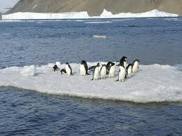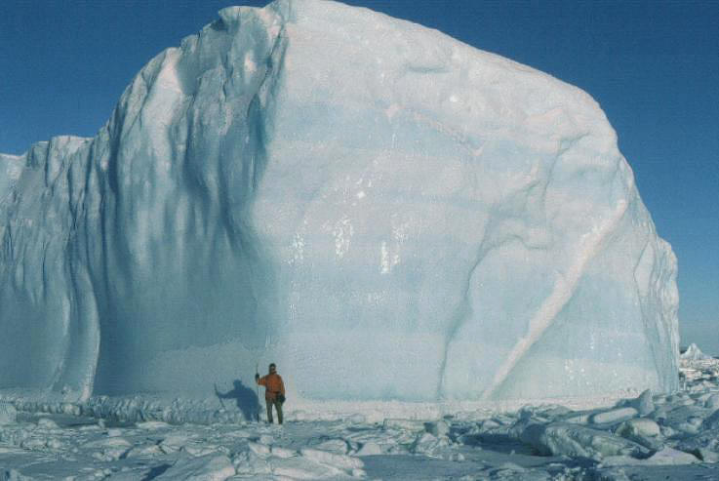

________________________ _____________________________

**Here’s a riddle for you! Q:** Why did the penguin cross the road ? Answer is on the back. ☺

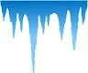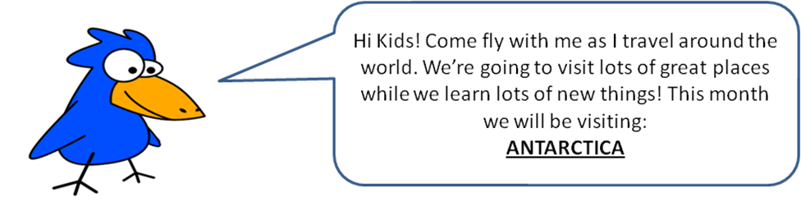

For more of a challenge, TRY THIS:

What do you think will happen if you place an ice cube in a glass of water? (Prediction)

Will it float? Sink?

___________________________________________________________________________________

Place an ice cube in a glass of water. (Procedure)

How much of the ice cube is on top of the water? How much of the ice cube is under the water?

______________________________________ ______________________________________

Try adding salt to the water. Did anything change?

____________________________________________________________________________________

____________________________________________________________________________________

____________________________________________________________________________________

**Draw and/or write about what happened.** (Observation/Conclusion)

____________________________________________________________________________________

____________________________________________________________________________________

____________________________________________________________________________________

____________________________________________________________________________________

____________________________________________________________________________________

____________________________________________________________________________________

Riddle answer: To go with the **floe**  . ☺

